Rt Hon Jeremy Hunt MP

Secretary of State for Health and Social Care

Department of Health and Social Care

39 Victoria St

London

SW1H 0EU

cc. Steve Brine MP, Parliamentary Under Secretary of State for Public Health & Primary Care; Cally Palmer CBE, National Cancer Director, NHS England

Thursday 31st May 2018

**Children and Young People Cancer Coalition – progress for children and young people with cancer, and their families**

Dear Secretary of State,

We are writing to you as CEOs of a newly formed Coalition – the Children and Young People Cancer Coalition (CYPC Coalition) – to highlight areas where progress has been made for children and young people with cancer and where we believe progress is still needed; and to request a meeting to discuss this with you and your Department.

Every day 11 children and young people are diagnosed with cancer in the UK, that’s over 4,000 diagnoses every year. 4 out of 5 children and young people will survive cancer for five years or more, but 10 children and young people still die every week from cancer in the UK. There are age-specific challenges for both children and young people with cancer and their families which we believe require recognition and action at a national level. The CYPC Coalition is a CEO-led charity Coalition which aims to improve outcomes for children, teenagers and young adults with cancer through having a unified voice; speaking up on issues that matter to our beneficiaries; offering mutual support between charities; sharing good practice and reducing duplication between organisations.

As you will be aware May 2018 marks two years since NHS England published [*Achieving World Class Cancer Outcomes: Taking the strategy forward*](https://www.england.nhs.uk/wp-content/uploads/2016/05/cancer-strategy.pdf) which sets out the ambitions for cancer treatment and services up until 2020. We believe that there have been many areas of progress for children and young people with cancer but also wanted to raise areas where progress has not been made.

We welcome the progress that has been made in the areas below.

* **Service review for children and young people with cancer -** we recognise the huge amount of work that has been done by the Children and Young People’s Clinical Reference Group in conducting a review of services for children and young people with cancer. We look forward to engaging with the consultation on the review planned for Summer 2018 and believe that this is a valuable opportunity to improve patient experience as well as clinical outcomes for children, young people and their families.
* **Cancer patient experience data -** we also welcome the work that has been done in ensuring that we start capturing patient experience data from children with cancer and improve how we collect patient experience data from teenagers and young adults aged 16 to 24 years old. This is a vital piece of work in understanding their experiences and leading to improvements. We thank the Minister, Steve Brine MP, for his commitment that patient experience data will be collected from children with cancer in 2019/20 and look forward to supporting that process however we can. We also welcome the Minister’s commitment to the Cancer Patient Experience Survey (CPES) continuing in some form after 2018/19, and believe it is vital that we and other charities and patient groups are part of the discussions on ensuring any future model for CPES works for patients.
* **Tissue banking –** we understand that progress is now also being made in ensuring that all children and young people diagnosed will be asked for their consent for their data and tissue sample to be collected and used for research which is welcome.

There are still some areas where progress has been delayed or we are unclear what plans are in place:

* **Improving experience of diagnosis –** the Implementation Plan commits to undertaking a Significant Event Analysis for every cancer diagnosis made by emergency admission. Children and young people are overrepresented in those cancer patients who are diagnosed through emergency admission but we are unclear about the progress against this recommendation or how children and young people’s experiences will be included in the piece of work.
* **Access to clinical trials –** access to clinical trials for children, teenagers and young adults with cancer remains an issue. The Implementation Plan committed to improving access rates for teenagers and young adults and we would like to see this actioned as a priority.
* **Recovery package –** we welcome the development of the recovery package for all cancer patients. We believe that children and young people with cancer would benefit from tailored recovery packages and would appreciate clarity on how this could be taken forward.
* **Workforce and CNS –** we welcome the publication of the Cancer Workforce report by Health Education England in 2017 and would welcome an update on progress in ensuring every child or young person has access to a Cancer Nurse Specialist.
* **Education about cancer in schools** – the Cancer Strategy recommended that NHS England and Public Health England consider the evidence-base for education about cancer in schools. With prevention of cancer being such a key focus for health services we would like to know about progress on this.
* **Access to psychological support** – the Cancer Strategy rightly identifies the importance of emotional and psychological support for people with cancer. This is particularly important for young people and their families and we would welcome an update on how their needs will be met in this area.
* **Access to palliative care** - the Implementation Plan states that in 2017/18 NHS England would pilot Holistic Needs Assessments as a means of ensuring access to palliative care. [Evidence shows that children and their families face a postcode lottery in access to palliative care](http://www.togetherforshortlives.org.uk/changing-lives/speaking-up-for-children/policy-advocacy/commissioning-england-2017/) and we would welcome information on how you will ensure every child or young person receives the palliative care they need.

We recognise and appreciate the investment Government and the NHS have made into improving the experiences and outcomes of children and young people with cancer and believe that this is paying off already. However, to ensure that progress continues we would appreciate an update from you on how the issues above will be prioritised over the next two years to ensure that every child or young person diagnosed with cancer receives world class cancer treatment and experience.

We look forward to hearing from you. To get in touch with the Coalition please contact the Chair, Kate Lee (CEO of CLIC Sargent), on [kate.lee@clicsargent.org.uk](mailto:kate.lee@clicsargent.org.uk).

Best wishes,

Members of the Children and Young People Cancer Coalition



Kate Lee

CEO CLIC Sargent

Chair, CYPC Coalition

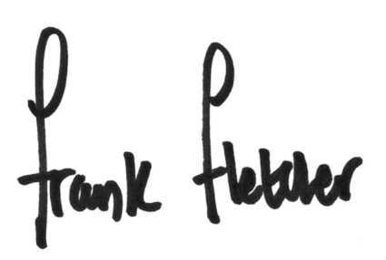

Frank Fletcher

CEO, Ellen MacArthur Cancer Trust

Vice Chair, CYPC Coalition



Sue Farrington Smith MBE

CEO, Brain Tumour Research

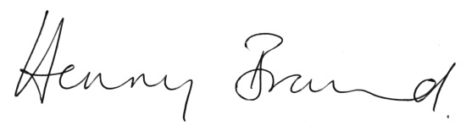

Henny Braund

Chief Executive, Anthony Nolan



Kate Collins

CEO, Teenage Cancer Trust



Ashley Gamble

CEO, Children’s Cancer and Leukaemia Group, Teenagers and Young Adults with Cancer



Barbara Gelb

CEO, Together For Short Lives



William Jones,

CEO, brainstrust

cid:image003.jpg@01D3F1A5.E6248FD0

Sarah Lindsell

CEO, Brain Tumour Charity



Chris Lewis

SimPal

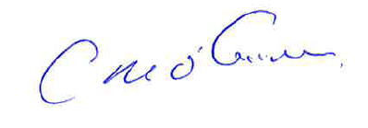

Cliff O’Gorman

CEO, Children with Cancer UK

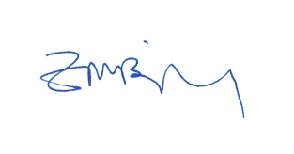

Zillah Bingley

CEO, The Rainbow Trust



Gemma Peters

CEO, Bloodwise



Stephen Richards

CEO, Solving Kids Cancer

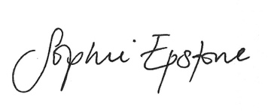

Sophie Epstone,

CEO, Trekstok